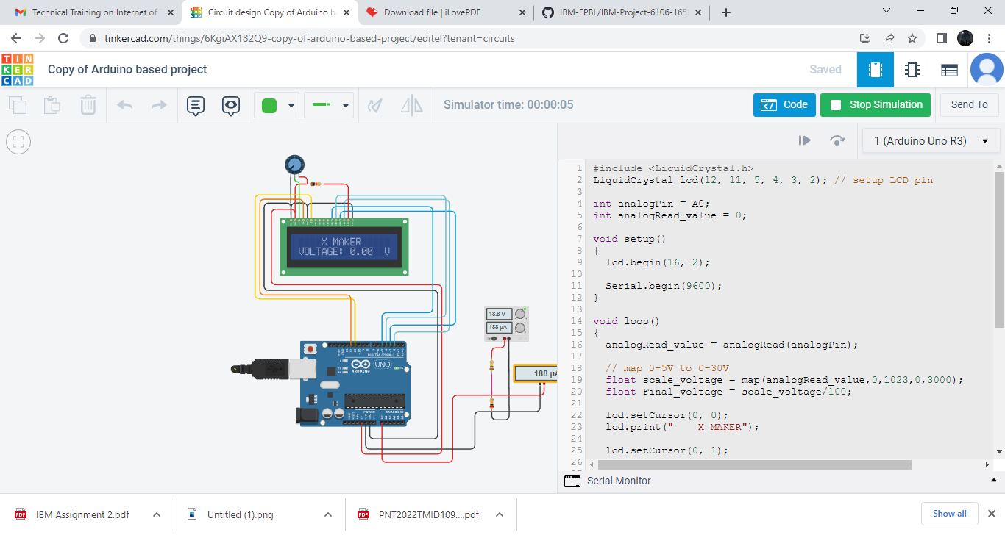

#include <LiquidCrystal.h>

LiquidCrystal lcd(12, 11, 5, 4, 3, 2); // setup LCD pin

int analogPin = A0;

int analogRead_value = 0;

void setup()

{

lcd.begin(16, 2);

Serial.begin(9600);

}

void loop()

{

analogRead_value = analogRead(analogPin);

// map 0-5V to 0-30V

float scale_voltage = map(analogRead_value,0,1023,0,3000);

float Final_voltage = scale_voltage/100;

lcd.setCursor(0, 0);

lcd.print(" X MAKER");

lcd.setCursor(0, 1);

lcd.print("VOLTAGE: ");

lcd.print(Final_voltage);

lcd.print(" ");

lcd.setCursor(15, 1);

lcd.print("V");

Serial.print(Final_voltage); // for using with serial ploter

Serial.print(" ");

Serial.print(0.00);

Serial.print(" ");

Serial.println(30.00);

delay(250);

//lcd.clear();

}

// Coding by Xmaker Channel, giveaway as public dogmain free of use, no waranty

// Follwing us at: https://www.youtube.com/watch?v=QOdq2mdxB7M